Giang Duong – ID 014533857

Assignment 5 – CS 271

Professor Mark Stamp

Q1.

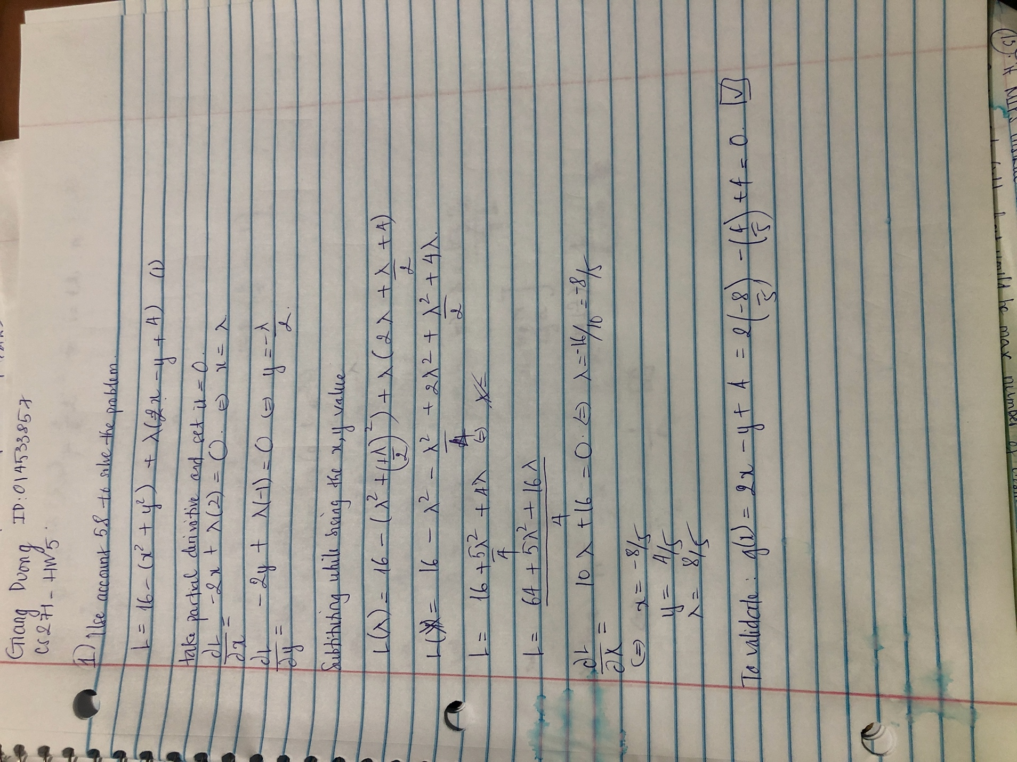

Q3/

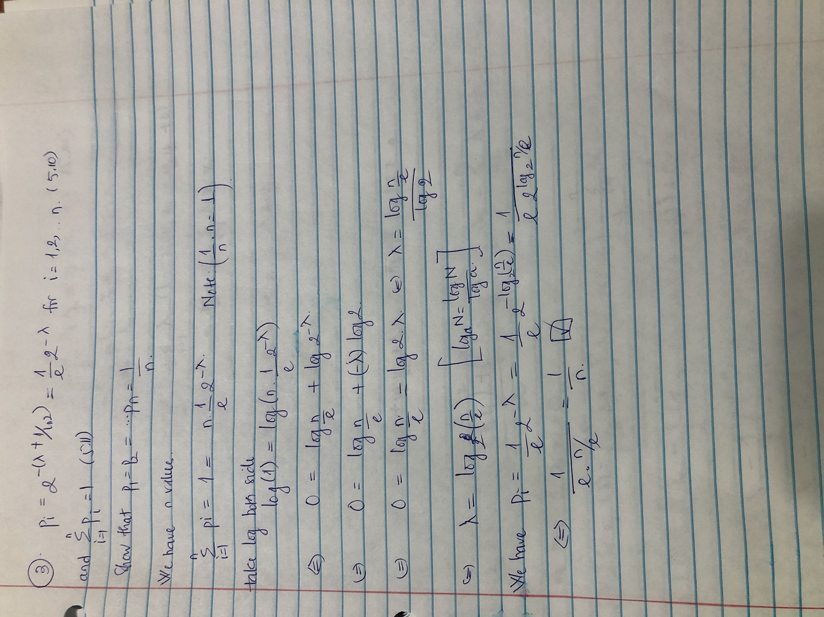

Q4/

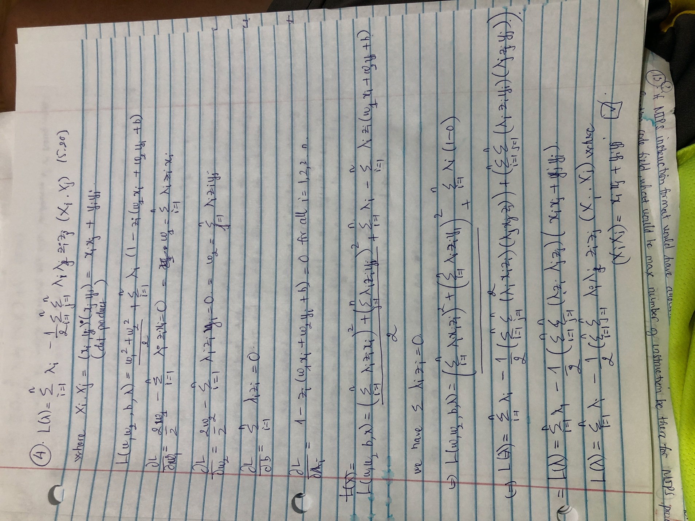

Q9/



9.b.

When we train the SVM for determine the weight of each feature. The weight states the more important of each features and hence the more it weights, the more it is important. Apply in this, we can eliminate the lower weight of each features when compared to others and can achive the dimensionality reducetion.

9.c.

PCA:

While working with PCA, we are reduced noises and determine the important in terms of Principal Component which uses the linear combination of features. We will not get the direct values of importance weight of the featurs and so it will be hard to say which features are important. Because of that, it will be difficult to archive dimesionality reduction in terms of features.

The eigenvectors and eigenvalues can be calculated from Covariance matrix ( higher the value, higher the variance, more important features) and then there will no requires for trainning.

SVM:

Cons:

The weights of the model are determined after performing the trainning.

Pros:

When we get the weight of each features then we can eleminate the feature based on its weights.

**10.a.**

C = 1.0, p= 2

[0 1 0 1 0 1 0 1 0 1 0 1 0 1 0 0 0 1 0 1 0 1 0 1 0 1 0 1 0 1 0 1 0 1 0 1 0

1 0]

**0.9743589743589743**

10.b.

C = 3.0, p= 2

[0 1 0 1 0 1 0 1 0 1 0 1 0 1 0 0 0 1 0 1 0 1 0 1 0 1 0 1 0 1 0 1 0 1 0 1 0

1 0]

**0.9743589743589743**

10.c.

C = 1.0, p= 4

[0 1 0 1 0 1 0 1 0 1 0 1 0 1 0 0 1 1 1 1 0 1 0 1 0 1 0 1 0 1 0 1 0 1 0 1 0

1 0]

**0.9230769230769231**

10.d.

C = 3.0, p= 4

[0 1 0 1 0 1 0 1 0 1 0 1 0 1 0 0 1 1 1 1 0 1 0 1 0 1 0 1 0 1 0 1 0 1 0 1 0

1 0]

**0.9230769230769231**

**q11./**

[0 1 0 1 0 1 0 1 0 1 0 1 0 1 0 0 0 1 0 1 0 1 0 1 0 1 0 1 0 1 0 0 0 1 0 1 0

1 0]

**0.9487179487179487**

[0 1 0 1 0 1 0 1 0 1 0 1 0 1 0 0 0 1 0 1 0 1 0 1 0 1 0 1 0 1 0 0 0 1 0 1 0

1 0]

**0.9487179487179487**

[0 1 0 1 0 1 0 1 0 1 0 1 0 1 0 0 0 1 0 1 0 1 0 1 0 1 0 1 0 1 0 0 0 1 0 1 0

1 0]

**0.9487179487179487**

[0 1 0 1 0 1 0 1 0 1 0 1 0 1 0 0 0 1 0 1 0 1 0 1 0 1 0 1 0 0 0 0 0 1 0 1 0

1 0]

**0.9230769230769231**

[0 1 0 1 0 1 0 1 0 1 0 1 0 1 0 0 0 1 0 1 0 1 0 1 0 1 0 1 0 1 0 1 0 1 0 1 0

1 0]

**0.9743589743589743**

[0 1 0 1 0 1 0 1 0 1 0 1 0 1 0 0 0 1 0 1 0 1 0 1 0 1 0 1 0 1 0 1 0 1 0 1 0

1 0]

**0.9743589743589743**

[0 1 0 1 0 1 0 1 0 1 0 1 0 1 0 0 0 1 0 1 0 1 0 1 0 1 0 1 0 1 0 1 0 1 0 1 0

1 0]

**0.9743589743589743**

[0 1 0 1 0 1 0 1 0 1 0 1 0 1 0 0 0 1 0 1 0 1 0 1 0 1 0 1 0 1 0 1 0 1 0 1 0

1 0]

**0.9743589743589743**

[0 1 0 1 0 1 0 1 0 1 0 1 0 1 0 0 0 1 0 1 0 1 0 1 0 1 0 1 0 1 0 1 0 1 0 1 0

1 0]

**0.9743589743589743**

[0 1 0 1 0 1 0 1 0 1 0 1 0 1 0 0 0 1 0 1 0 1 0 1 0 1 0 1 0 1 0 1 0 1 0 1 0

1 0]

**0.9743589743589743**

[0 1 0 1 0 1 0 1 0 1 0 1 0 1 0 0 0 1 0 1 0 1 0 1 0 1 0 1 0 1 0 1 0 1 0 1 0

1 0]

**0.9743589743589743**

[0 1 0 1 0 1 0 1 0 1 0 1 0 1 0 0 0 1 0 1 0 1 0 1 0 1 0 1 0 1 0 1 0 1 0 1 0

1 0]

**0.9743589743589743**

[0 1 0 1 0 1 0 1 0 1 0 1 0 1 0 0 0 1 0 1 0 1 0 1 0 1 0 1 0 1 0 1 0 1 0 1 0

1 0]

**0.9743589743589743**

[0 1 0 1 0 1 0 1 0 1 0 1 0 1 0 0 0 1 0 1 0 1 0 1 0 1 0 1 0 1 0 1 0 1 0 1 0

1 0]

**0.9743589743589743**

[0 1 0 1 0 1 0 1 0 1 0 1 0 1 0 0 0 1 0 1 0 1 0 1 0 1 0 1 0 1 0 1 0 1 0 1 0

1 0]

**0.9743589743589743**

[0 1 0 1 0 1 0 1 0 1 0 1 0 1 0 0 0 1 0 1 0 1 0 1 0 1 0 1 0 1 0 1 0 1 0 1 0

1 0]

**0.9743589743589743**

q12./

**With all 3 features**

**0.9487179487179487**

**Respective Weights of HMM, SSD, OGS**

**[[ 0.19688024 -0.53494025 -0.70487142]]**

**The most important weight is OGS score when the least important weight is HMM score**

**Accuracy after removing the HMM feature ->**

**0.9487179487179487**

**Respective Weights of SSD, OGS**

**[[-2.44489465 -2.24186897]]**

**Accuracy after removing the HMM and OGS feature ->**

**0.9487179487179487**

**Weight of SSD**

**[[-3.87596913]]**

**q15.a**

**[0. 0. 2.5 0. 1.25 1.25]**

**-5.999999999999998**

**F[0] = 1.4999999999999982**

**z[0] = 1**

**F[1] = 2.7499999999999982**

**z[1] = 1**

**F[2] = 0.2500000000000018**

**z[2] = 1**

**F[3] = -3.499999999999999**

**z[3] = -1**

**F[4] = -1.0**

**z[4] = -1**

**F[5] = -1.0**

**z[5] = -1**

**q15.b**

**[1.32173539 0. 3.09731961 0. 1.91905501 2.5 ]**

**-15.60197599369006**

**15.c.**

**Part a, we have b = -5.999999999999998 so the eqs for hyperplane is x + y = -5.999999999999998**

**Part b, we have b = -15.60197599369006 so the eqs for hyperplane is x + y = -15.60197599369006**

|  |  |  |
| --- | --- | --- |
| group | x | y |
| A | 3 | 3 |
| A | 3 | 4 |
| A | 2 | 3 |
| B | 1 | 1 |
| B | 1 | 3 |
| B | 2 | 2 |

REFERENCES

1. M. Stamp, “Introduction to Machine Learning with Applications in Information Security.”
2. Steven A.Cohen and Matthew W.Granade, “Models will run the world”